
COMP – 7745 MACHINE LEARNING
ENHANCING SKIN CANCER DETECTION THROUGH DEEP LEARNING TECHNOLOGIES

Satya Akhil Torlikonda U00924200

SUBMISSION DATE
04/30/2024

Contents
Abstract 2
I. Introduction 3
a. Problem Definition 3
b. Background Study or Related Works 3
Research Gap: 4
c. Objectives and Contribution 4
II. Methodology 6
a. Data Preprocessing 6
b. Model Development 6
c. Model Training 6
d. Model Evaluation 6
III. Model Descriptions 8
a. Convolutional Neural Network (CNN) 8
Model Structure: 8
b. MobileNet Architecture 8
Model Structure: 8
IV. Results and Experiments 9
a. Database 9
b. Training and Testing Logs 9
c. Discussion and comparison 11
d. Model comparison 11
V. Conclusion 12
a. Future Work 12
VI. References 13

Abstract
This study suggests developing a deep learning model that functions on Convolutional Neural Networks along with MobileNet architecture to improve the precision and effectiveness of skin cancer detection from images. The growing incidence of skin cancer worldwide highlights the significance of timely identification for improving treatment results. Traditional diagnostic techniques such as eye inspections and biopsies are prone to inaccuracies and require a significant amount of time. This research uses a Convolutional Neural Network (CNN) model specifically designed for classifying skin cancers. It also integrates MobileNet to enhance performance on mobile devices and allows for real-time as well as portable diagnostics. The models are assessed using metrics that are used in classification such as accuracy, precision, recall as well as F1 score. The results demonstrate that both CNN and MobileNet models exhibit strong performance with accuracies of 0.87 and 0.86 respectively. Future research includes carrying out experiments with different architectures, augmenting regularization techniques, using transfer learning and exploring hybrid models to further enhance the model's performance and ability to generalize.
Keywords – CNN, MobileNet, hybrid models, F1 score, transfer learning, etc.

Introduction
Skin cancer is a very common type of cancer that is prevalent worldwide and its occurrence rates are consistently rising annually. The importance of early detection cannot be emphasized because it significantly enhances the prospects and treatment outcomes for patients (Abu Owida, 2022). Traditional diagnostic techniques, such as visual inspections and biopsies are not only time-consuming but also susceptible to errors. In order to tackle these difficulties, this research suggests the development of a powerful deep learning model. The model employs Convolutional Neural Networks (CNNs) and the MobileNet architecture to automate and improve the precision and effectiveness of skin cancer detection from images.

Problem Definition
This project seeks to address the rising prevalence of skin cancer by creating a more precise, effective and fast technique for identifying possibly cancerous skin lesions. Standard diagnostic techniques, such as eye examinations and biopsies are frequently time-consuming and prone to human mistakes, resulting in treatment delays and potentially unfavorable results for patients. The suggested approach involves developing a deep learning model that integrates Convolutional Neural Networks (CNNs) with the MobileNet architecture. The purpose of this model is to automate the process of detecting, improve the accuracy of diagnosis and enable real-time, portable diagnostics on mobile devices. The objective of this strategy is to substantially decrease the time it takes to diagnose skin cancer and enhance the dependability of the screening process. Ultimately, this will assist in detecting the disease at an early stage and improving the management of patients.

Background Study or Related Works
The use of deep learning in medical imaging has fundamentally transformed the ability to diagnose medical conditions, particularly with CNNs leading the way (Gouda et al., 2022). These networks are well-suited for tasks involving image identification and are increasingly being used in the medical profession to assess and classify different forms of medical imaging. Convolutional Neural Networks are very effective at distinguishing and classifying various forms of skin lesions, which is essential for precise diagnosis of skin cancer. By incorporating the MobileNet architecture, the model is enhanced to better fit mobile devices, guaranteeing that the solution is efficient and easily accessible. This enables the possibility of conducting real-time and on-the-go diagnosis.
The authors (Gouda et al., 2022) developed a model that can classify skin lesions that categorized lesions in 2 different classes which are benign and malignant. The system was implemented in three different distinct phases. In the initial stage, a neural network which depends on self generation was used in order to extract lesions from images. During the second step, several features of the tumor including its boundary, texture as well as color details were retrieved. A total of nearly 57 features from the data were extracted by the algorithm, which included 7 new features specifically linked to describing lesion borders. The author used PCA method which was employed to decrease the number of dimensions in the features, resulting in the identification of the most suitable set of features. In the final stage, lesions were differentiated using a neural network ensemble model. The ensemble neural network enhances classification accuracy by integrating the backpropagation neural network (BPNN) and fuzzy neural networks. In addition, the classification results which were developed and extracted from the proposed system were then compared along with other models that already existing, including SVM, KNN, random forest, Adaboot and others. The suggested model achieved accuracy above 90%, which was almost 7.5% higher in terms of sensitivity compared to the other classifiers.
Another research (Shuaib, Osaghae and Frederick, 2022) presented a new approach for detecting skin cancer using a genetic algorithm (GA) as well as Neural network such as ANN methods. The author cleaned the images to remove hair using medical imaging software called Dull-Rozar. From this approach, the region of interest (ROI) was then extracted using the Otsu thresholding approach. In addition, the GLCM approach was used to extract distinct features of the segmented images. Later on, a hybrid ANN method as well as a genetic algorithm (GA) classifier was used to classify lesion images into two categories: malignant as well as benign. The proposed system attained an aggregate accuracy rate of 88%.
The research (Kato et al., 2019) focuses on the classification of two distinct forms of skin cancer: melanoma and non-melanoma. Instead of simply using either color or grayscale images, a blend of both was employed to achieve superior outcomes. Segmentation is achieved through the use of k-means clustering, while the ABCD approach (which assesses Asymmetry, Boundary irregularity, color and Diameter) is also employed. A total of 150 images were used, with 75 images classified as melanoma and 75 images classified as non-melanoma. The performance evaluation is conducted using four classifiers like SVC and 1-NN. Both classifiers attained the best accuracy using the same number of features.
The paper (Samaneh Azargoshasb et al., 2021) presents a 3D reconstruction approach that uses 2D images to recognize the shape and RGB information of the 3D image. Images undergo pre-processing and are transformed into binary images consisting of 0s as well as 1s. The algorithm namely adaptive snake is used for segmenting images. In addition to the various features, a depth estimation parameter based on 3D technology is employed to enhance the efficiency of classification.
The most effective approach to minimize the impact of melanoma is to diagnose it in its early stages. This paper (Tian, Zhao and Zheng, 2021) examines one of the ways that uses the MVSM classifier. The suggested method groups and considers five distinct forms of skin lesions, namely actinic keratosis, Squamous Cell Cancer, Basal Cell Cancer, Seborrhoeic Verruca and Nevocytic nevus. The GLCM (Gray-Level Co-occurrence Matrix) is used for the extraction of color and texture characteristics including contrast, gradient and homogeneity. K-means clustering is used to achieve segmentation. The tumor area was computed for each of the five image categories. The GUI displays the classification and segmentation results.

Research Gap:
- Mobile Optimization: There is a lack of extensive study on the process of optimizing CNN models specifically for mobile devices. This research is important since it enables real-time and portable diagnostics.
- Real-Time Capabilities: There is a requirement for models that have the ability to perform analysis in real-time in order to provide instant diagnostic feedback.
- Generalization and robustness: These are key factors in determining the practical applicability of models in various clinical contexts. It is often observed that many models lack resilience and struggle when faced with fresh and unexplored data.
- False Positives and Negatives: Recurrent problems with diagnosis that are crucial for precise patient treatment in medical settings.
- Comparisons of Architectures: Not enough research has been done to compare various deep learning architectures in order to identify the best models for skin lesion imaging.

Objectives and Contribution
The main goals of this project are:
- Enhance Detection Accuracy: Employ advanced deep learning algorithms to outperform traditional diagnostic approaches.
- Reduce Diagnosis Time: Reduce the amount of time needed to diagnose skin cancer for enabling faster decisions regarding treatment.
- Scalability and Integration: Develop a model that can be expanded efficiently and seamlessly included into current medical diagnostic frameworks and mobile applications.
By accomplishing the above-mentioned objectives, the following contributions will be made by this project:
- Improve diagnosis Accuracy: The research employs sophisticated deep learning algorithms that combine CNNs with MobileNet architecture to greatly enhance the precision of skin cancer diagnosis compared to conventional diagnostic methods.
- Reduced Diagnosis Time: The research significantly reduces the time needed to identify skin lesions by allowing real-time analysis and diagnosis on mobile devices. This enables faster treatment decisions and has the potential to enhance patient outcomes.
- Scalability and Integration: The model's scalability and integration with existing medical diagnostic frameworks and mobile applications improve accessibility and efficiency in skin cancer screening across clinical settings.

Methodology

Data Preprocessing
The first step is preparing the dataset to enhance the efficiency of the training process for the deep learning model. This includes:
- Importing Libraries: TensorFlow and the required modules were imported from TensorFlow.keras.applications and TensorFlow.keras.preprocessing.image.
- Defining Constants: We established constants for the batch size (32) and image dimensions (224 × 224 pixels).
- Data Generators: For both training and testing data, we built instances of ImageDataGenerator. The training data generator was subjected to several data augmentation techniques, such as rotation, rescaling, horizontal flipping, shear range, zoom range, and shifting of width and height. Only rescaling was done for the testing data generator.
- Scaling: All images will be uniformly downsized to maintain a consistent input size for the Convolutional Neural Network model. MobileNet necessitates precise input dimensions of 224x224 pixels.
- Flow from Directory: For both training and testing data generators, we loaded data from directories using the flow_from_directory method. Target size, batch size as well as class mode ('categorical' as there are several classes) were supplied as were the links to the folders holding the training and testing images.

Model Development
The development of the skin cancer detection model will be conducted in two primary stages:
- CNN Model: A customized CNN model will be built from scratch exclusively for skin lesion classification. The model will incorporate many convolutional layers to extract distinctive features from images, pooling layers to decrease the spatial dimensions and fully connected layers to group the retrieved features into various skin cancer classes.
- MobileNet Architecture: The MobileNet architecture will be used to increase the model's efficiency. MobileNet is specifically developed for vision applications on mobile and embedded devices. It achieves this by using depth-wise separable convolutions which effectively reduces the amount of parameters and computing requirements. As a result, MobileNet is highly suitable for running on mobile devices.

Model Training
- Dataset Splitting: The dataset will be split into separate training set allocated for training purposes and test set reserved for testing.
- Model Training: The training dataset will be used to train the CNN and MobileNet models. This stage includes adjusting certain hyperparameters, such as the learning rate, number of epochs and batch size in order to enhance performance.

Model Evaluation
After the completion of training, the model will undergo evaluation using an unseen test set. Important performance metrics for evaluating the effectiveness of the model include:
- Accuracy: The proportion of correct forecasts.
- Precision and recall: Especially crucial in medical diagnostics to reduce false positives and negatives.
- F1 Score: The harmonic mean of recall as well as precision and which provides a balance between the two in cases of uneven class distributions.

Model Descriptions

Convolutional Neural Network (CNN)
A Convolutional Neural Network (CNN) is a complex machine learning system that can process an input image, assign significance (adjustable weights and biases) to different elements/objects in the image and distinguish between them (Taki Hasan Rafi and Shubair, 2021). The pre-processing requirements for a CNN are significantly lower in comparison to other classification algorithms. Unlike primitive approaches where filters are manually designed, CNNs can acquire these filters/characteristics through training.

Model Structure:
- Input Layer: Accepts preprocessed images that have been scaled to meet network requirements (e.g., 224x224 pixels for consistency).
- Convolutional Layers: Employ many filters to process the input and provide a feature map that highlights the existence of identified features in the input.
- Activation Functions (ReLU): Introduce non-linearities within the network which helps in learning complex patterns.
- Pooling layers: The layer minimizes the spatial dimensions in the form of width and height of the input volume for the subsequent convolutional layer. It is also performed to prevent overfitting.
- Fully Connected Layers: These layers link each neuron in one layer to every other layer's neuron and are mostly employed at the network's conclusion to classify the features that the CNN has learnt into different groups according to the training dataset.
- Output Layer: Classifies the input image into several classes depending on the training using a softmax activation function.

MobileNet Architecture
MobileNet refers to a class of efficient models which is designed for various mobile as well as embedded vision applications (Kulkarni et al., 2021). The design is simplified and uses depth-wise separable convolutions to construct efficient deep neural networks.

Model Structure:
- Depth-wise Separable Convolution: This is the foundation of MobileNet. It includes a point-wise convolution after a depth-wise convolution. This factorization decreases both the computational requirements and the size of the model.
- Input Layer: Like CNNs, it accepts an image as input and resizes it to the dimensions required by the network which are usually 224x224 pixels.
- Convolutional Layers: Employ depth-wise separable convolutions which divide the convolution into two distinct layers: one for filtering and another for combining.
- Pooling Layers: Added at different network points to minimize representation size and expedite calculation.
- Fully Connected Layer: This layer is added to the end of the neural network, just before the output layer. Its purpose is to classify the image by assigning it to one of the predefined labels.
- Output Layer: A softmax function is typically used in the output layer for multi-class classification.
MobileNet is intended to be lightweight and efficient, so it can operate well on mobile devices with limited computational resources. It balances model size and precision by changing two hyperparameters: the width multiplier and the resolution multiplier.

Results and Experiments

Database
The dataset consists of two types of skin cancer which consist of skin moles of benign and malignant type. In training image set, there are 1440 benign samples and 1197 malignant samples. In testing image set, there are 360 benign samples and 300 malignant samples. The images in this dataset are a proportionate combination of benign and malignant skin moles. The images are taken from the link
https://www.kaggle.com/datasets/fanconic/skin-cancer-malignant-vs-benign

Training and Testing Logs
The models tested are CNN and MobileNet which are evaluated depending on false positive and false negative predictions where precision, recall and F1 score are used for evaluation in test images.
- CNN Model Logs
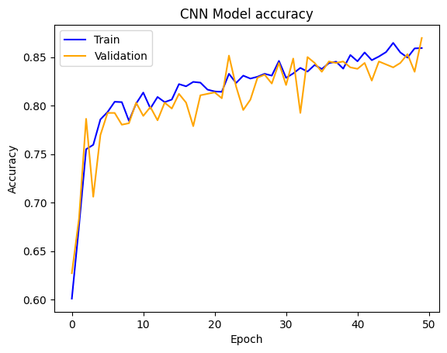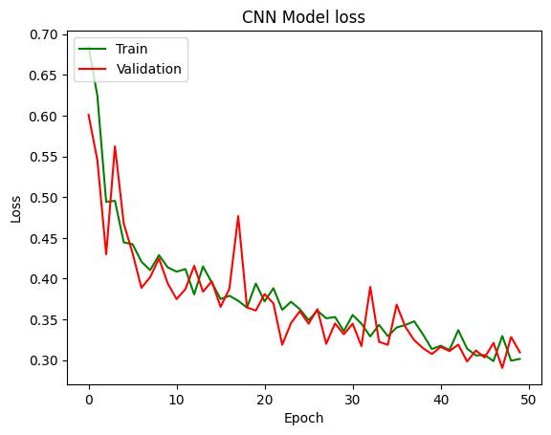
Figure 1: Model accuracy and loss of CNN model
In general, as the epochs progress, both training and validation losses decrease corresponding to that the model is gaining knowledge and advancing. Initial epochs exhibit significant fluctuations or higher loss values, indicating that the model is undergoing adjustments during the early stages of training. Over time, the convergence of the loss curves for training and validation indicates that the model is not overfitting considerably. Minor fluctuations in validation data or overfitting may account for certain increases in validation loss.
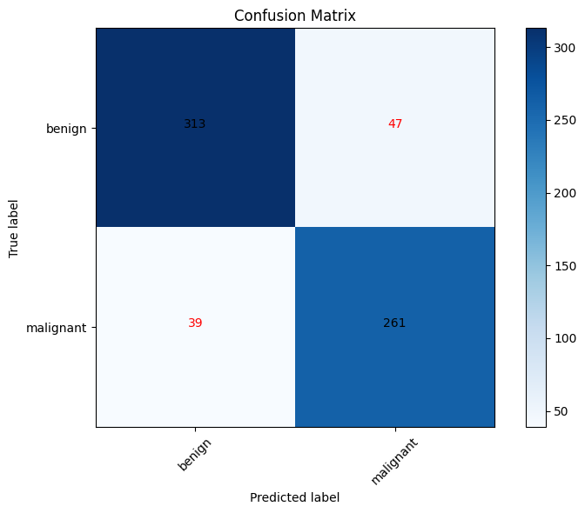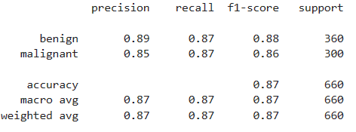
Figure 2: Misclassification report of CNN models
The confusion matrix demonstrates a high proportion of accurate classifications for both malignant as well as benign cases indicating a strong performance overall. The existence of false positives as well as false negatives indicates that further development is required. In medical applications, it is critical to minimize false negatives which represent malignant cases that were overlooked.
The performance is well-balanced as evidenced by the metrics which demonstrate comparatively high precision, recall, and F1-score for both malignant and benign classifications. A 0.87 accuracy value indicates that the model classifies skin cancer cases adequately on average.
The higher precision observed for benign cases in comparison to malignant cases suggests that the model conveys a marginally improved ability to prevent false positives in benign cases. The recall rates for both classes are equivalent demonstrating that positive cases are consistently detected.
- MobileNet Model Logs
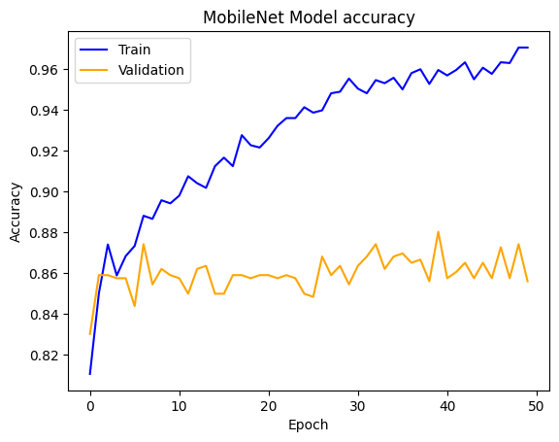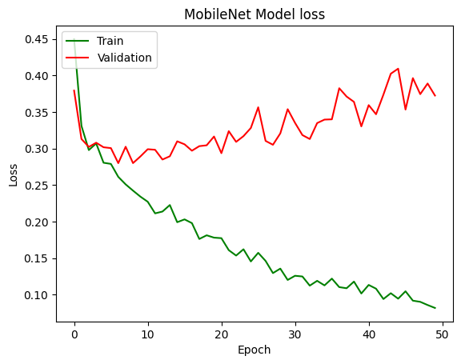
Figure 3: Model accuracy and loss of Mobilenet model
The loss and accuracy plots of the MobileNet model indicate that it is learning efficiently although with indications of overfitting. The fluctuations in validation loss and accuracy suggest that generalization could be improved.
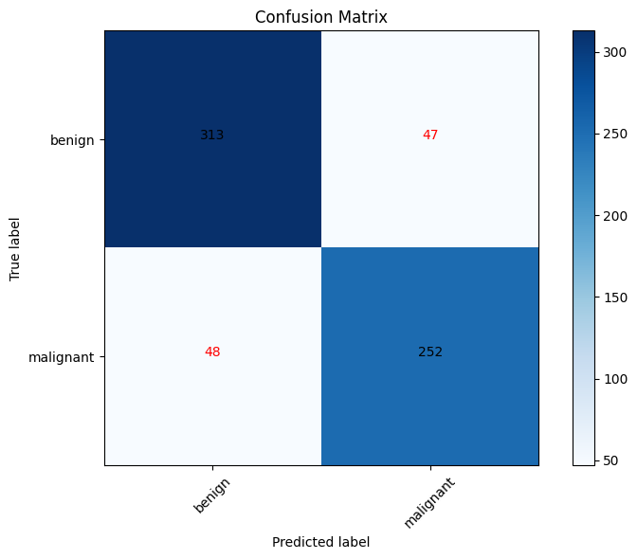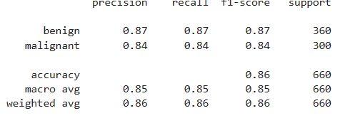
Figure 4: Misclassification report of MobileNet model
With an aggregate accuracy of 0.86, 86% of predictions were accurate.
The MobileNet model exhibits remarkable performance, as evidenced by its well-balanced performance in terms of precision, recall and F1-score for classification metrics. Effective learning is indicated by the confusion matrix, which reveals a greater number of accurate classifications for both benign as well as malignant cases.

Discussion and comparison
The success and potential areas for improvement of the CNN and MobileNet models in distinguishing benign from malignant skin cancer lesions were revealed through the execution of experiments. An assessment was conducted on both models using confusion matrices, F1-score, precision, and recall, with an emphasis on minimizing misclassifications in medical contexts.
The accuracy and loss of the CNN model revealed consistent growth which indicated effective learning. The convergence between the two phases of validation and training losses and the downward trend of the loss curve indicate that the model acquires knowledge without experiencing considerable overfitting.
The accuracy during both training and validation increased in parallel, even with slight variations signaling consistent performance with a potential for overfitting. The CNN model demonstrates a considerable percentage of accurate classifications in its confusion matrix, though with a minor presence of false positives and false negatives. While the precision, recall and F1-score showed relatively high values, the misclassifications demonstrated potential for improvement, particularly in the context of reducing False Negatives in medical applications.
The MobileNet model demonstrated robust learning capabilities; however, it exhibited some variations in validation loss and accuracy which indicate the possibility of overfitting. Although the accuracy during training improved steadily, the variability in the accuracy during validation suggested that more generalization was required. Similar to the CNN model, the MobileNet confusion matrix demonstrated an important proportion of accurate classifications. Although the model demonstrated strong performance as evidenced by the precision, recall, and F1-score, the variability observed in the validation metrics suggested possible unreliability in practical situations.

Model comparison
In terms of confusion matrix, the CNN model had 47 False Positives (benign cases predicted as malignant) and 39 False Negatives (malignant cases predicted as benign).
The MobileNet model had 47 False Positives and 48 False Negatives which implies that the CNN model had slightly fewer misclassifications. As for the loss trend in the CNN model, a few steady decreases with some ups and downs implied that the learning was quite effective with relatively low overfitting. Sharp validation loss fluctuations are indicated by the model of MobileNet, which can likely be overfitting or generalization in the model. In general, it seems that the CNN model works better in this case: it has higher accuracy, less misclassification, and more stable trends of loss, which is the indication that probably it would be more credible for classification of skin cancer.

Conclusion
The CNN and MobileNet models have been proved to be very strong in classifying benign or malignant cases of skin cancer, with the accuracy rates being 0.87 and 0.86, respectively. In fact, this is balanced in the values of precision, recall, and F1 score, thus showing the credibility of both models in classifying skin cancer. However, both models have significant promise, and more fine-tuning could improve their accuracy and resilience particularly in mitigating false negatives and mitigating the risks of overfitting.
However, some major limitations exist:
- Overfitting
With such big validation losses and accuracies that fluctuate, one can make a supposition that this or that ability to overfit in the current case is quite large, especially for the MobileNet model. Further regularization or data augmentation might be needed.
- False Positives and False Negatives
Both of these models yield a good ratio of False Positives and False Negatives. False Negatives are critical and mainly undesirable in the medical context, where they most probably would represent the cases missed for malignant. Further reduction in these misclassifications would be very critical for improvements.
- Generalization
All these differences in accuracy hint that maybe generalization of the models can be improved, by increasing the diversity of the data and usage of better regularization techniques.

Future Work
- Experiment with Other Architectures
Try different convolutional neural network (CNN) architectures, such as ResNet, DenseNet, or EfficientNet, to see if they provide better performance.
- Implement Stronger Regularization
Apply regularization techniques like dropout, L2 regularization, or early stopping to mitigate overfitting, especially in models like MobileNet, which showed signs of overfitting.
- Use Transfer Learning
Explore transfer learning with pre-trained models, which can improve generalization and reduce training time by leveraging learned features from other large datasets.
- Hybrid Models
Experiment with hybrid models that combine different architectures or techniques to achieve a balance of accuracy, recall, and precision.

References
Abu Owida, H. (2022). Biomimetic Nanoscale Materials for Skin Cancer Therapy and Detection. Journal of Skin Cancer, 2022, pp.1–12. doi:https://doi.org/10.1155/2022/2961996.
Gouda, W., Sama, N.U., Al-Waakid, G., Humayun, M. and Jhanjhi, N.Z. (2022). Detection of Skin Cancer Based on Skin Lesion Images Using Deep Learning. Healthcare, 10(7), p.1183. doi:https://doi.org/10.3390/healthcare10071183.
Kato, J., Horimoto, K., Sato, S., Minowa, T. and Uhara, H. (2019). Dermoscopy of Melanoma and Non-melanoma Skin Cancers. Frontiers in Medicine, 6. doi:https://doi.org/10.3389/fmed.2019.00180.
Kulkarni, U., S.M., M., Gurlahosur, S.V. and Bhogar, G. (2021). Quantization Friendly MobileNet (QF-MobileNet) Architecture for Vision Based Applications on Embedded Platforms. Neural Networks, 136, pp.28–39. doi:https://doi.org/10.1016/j.neunet.2020.12.022.
Samaneh Azargoshasb, Molenaar, L., Rosiello, G., Buckle, T., Danny, Melissa, Welling, M.M., Alic, L., Leeuwen, van, Winter, A. and Oosterom, van (2021). Advancing intraoperative magnetic tracing using 3D freehand magnetic particle imaging. International journal of computer assisted radiology and surgery (Print), 17(1), pp.211–218. doi:https://doi.org/10.1007/s11548-021-02458-2.
Shuaib, I., Osaghae, E. and Frederick, B. (2022). Cancer Detection using Deep Learning: A Survey. Journal of Applied Artificial Intelligence, 3(1), pp.75–82. doi:https://doi.org/10.48185/jaai.v3i1.468.
Taki Hasan Rafi and Shubair, R.M. (2021). A Scaled-2D CNN for Skin Cancer Diagnosis. doi:https://doi.org/10.1109/cibcb49929.2021.9562888.
Tian, J., Zhao, J. and Zheng, C. (2021). Clustering of cancer data based on Stiefel manifold for multiple views. BMC bioinformatics, 22(1). doi:https://doi.org/10.1186/s12859-021-04195-4.

